**Claremore Neighborhoods Project**

1). Introduction

When people move to a new location they have to choose between multiple variables one of which is choosing between country versus city living. Each has pluses and minuses of their own. Living in the country means a more secluded life, quiet, clean air, maybe having horses on your property, livestock but then again you can be far from city amenities which would mean driving long distances to get to venues around your home and driving to and from work. Living in the city means being close to neighbors, noise, crime, but having a shorter drive to work as well as not having to drive a long distance for groceries, shopping etc.

This report looks at 14 neighborhoods around Claremore, OK and searches for how many venues are located at various Euclidian distances from the center of each neighborhoods and then looks at driving distance between the center of each neighborhood and selected points in Claremore as well as the neighboring city of Tulsa, OK.

The objective is to see how the distances that need to be driven to various venues around a neighborhood as well as to specific destinations in Claremore and Tulsa vary from one neighborhood to another. This is one factor that could be important in the selection of a neighborhood to live in. A secondary objective was to see if moving to Claremore would lead to a shorter driving distance to Grove, OK where the author’s wife’s sister lives than where we live now.

2). Data

The data that would be needed are:

a).The breakdown of the town into neighborhoods ([Claremore, OK Real Estate Market Data - NeighborhoodScout](https://www.neighborhoodscout.com/ok/claremore))

b). The latitude and longitude of the center of the neighborhoods as estimated by choosing the midpoint of the neighborhood ([www.google.com/maps](http://www.google.com/maps) ).

|  |  |  |  |
| --- | --- | --- | --- |
| Neighborhood | lat | long | lat_long |
| Bushyhead | 36.4301 | -95.5759 | 36.4301,-95.5759 |
| Sageeyah / Degroat | 36.3588 | -95.6331 | 36.3588,-95.6331 |
| Sequoyah | 36.3688 | -95.5074 | 36.3688,-95.5074 |
| Eastland dr / Blue Starr Dr | 36.3339 | -95.5568 | 36.3339,-95.5568 |
| Tiawah/Justice | 36.2966 | -95.505 | 36.2966,-95.5050 |
| Route 20 / N Lake Rd | 36.3097 | -95.59 | 36.3097,-95.5900 |
| Choctaw Ave / E 6th St | 36.3148 | -95.6046 | 36.3148,-95.6046 |
| Archer Dr / S Chambers | 36.316 | -95.6245 | 36.3160,-95.6245 |
| City Center | 36.2952 | -95.6205 | 36.2952,-95.6205 |
| Rogers State U / Route 88 | 36.3093 | -95.6498 | 36.3093,-95.6498 |
| W Blue Starr / N Moore | 36.3292 | -95.6219 | 36.3292,-95.6219 |
| Verdigris | 36.2497 | -95.6551 | 36.2497,-95.6551 |
| Catoosa | 36.1922 | -95.7234 | 36.1922,-95.7234 |
| Foyil | 36.4624 | -95.4453 | 36.4624,-95.4453 |

c).The latitude and longitude of specific locations in Claremore and in Tulsa. ([www.google.com/maps](http://www.google.com/maps)).

|  |  |
| --- | --- |
| **destination** | **lat_long** |
| Hillcrest Claremore | 36.32277,-95.60459 |
| Walmart Supercenter | 36.29439,-95.62802 |
| Claremore Post Office | 36.31808,-95.61022 |
| Will Rogers & Lynn Riggs Road | 36.31256,-95.61614 |
| Lowes | 36.28904,-95.63139 |
| On ramp I-44 north | 36.30692,-95.59303 |
| on ramp 1-44 south | 36.24158,-95.66688 |
| Grove, OK | 36.61838,-94.81090 |
| 71st & 169 | 36.06108,-95.86038 |
| Saint Francis Medical Center | 36.07227,-95.91994 |
| mid Tulsa | 36.1194,-95.86146 |
| west Tulsa | 36.06123,-96.00803 |

3). Methodology

First, <https://www.NeighborhoodScout.com/ok/claremore> was accessed to determine how to break-up the Claremore area into neighborhoods. In addition, Catoosa, Verdigris were added since they are in close proximity to the target Claremore neighborhoods.

Then, using <https://www.google.com/maps> was accessed to estimate the longitude and latitude of the center of each neighborhood and then this was plotted using folium

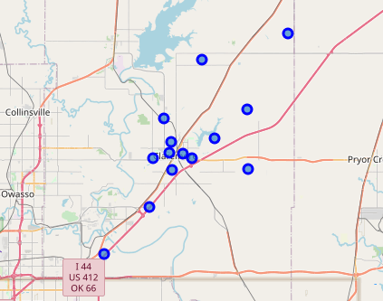

Then, again using <https://www.google.com/maps> was accessed to locate the latitude and longitude of specific locations in Claremore and Tulsa.

Using the Google distance matrix API, the driving distance between the center of each neighborhood and specific destinations in Claremore and Tulsa was acquired. Then the estimated frequency of driving to the various locations was used to calculate the estimated monthly mileage leading to the following table with the neighborhoods listed in increasing monthly mileage:

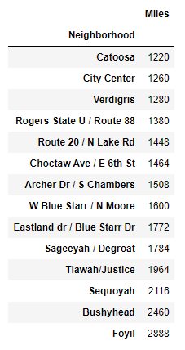

Using the FourSquare.com API, the venues located within 1, 2, 3, 5, and 10 miles from the center of each neighborhood were calculated. Because I wanted to get the distance that might be traveled to the closest 30 venues in a month to the center of each neighborhood, I needed to go out to 5 and 10 miles in order to get the needed venues since some neighborhoods were quite isolated and even at that there was one neighborhood that only had 12 venues within 10 miles (Foyil).

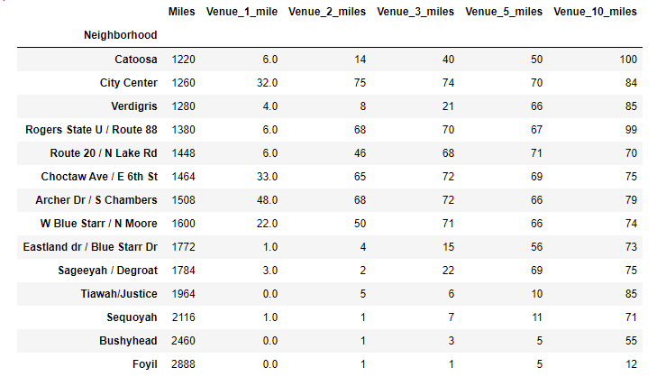

To get the number of unique venues for each distance calculated, the number from the lower distances was subtracted from the distance of interest.

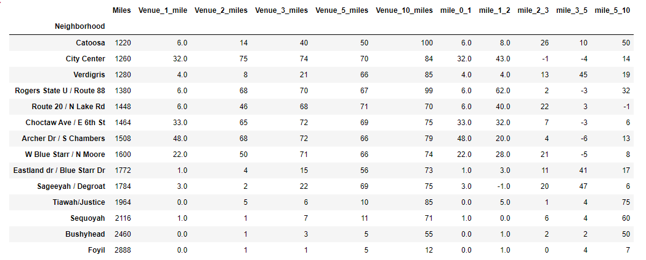

Then the distance traveled to and from each venue for each distance was calculated to get a rough approximation of distance traveled to the closest 30 venues a month. Then that mileage was added to the first mileage from the center of the neighborhood to specific locations in Claremore and Tulsa to get the final mileage. After sorting by total mileage, the total mileage order did not change among the neighborhoods.

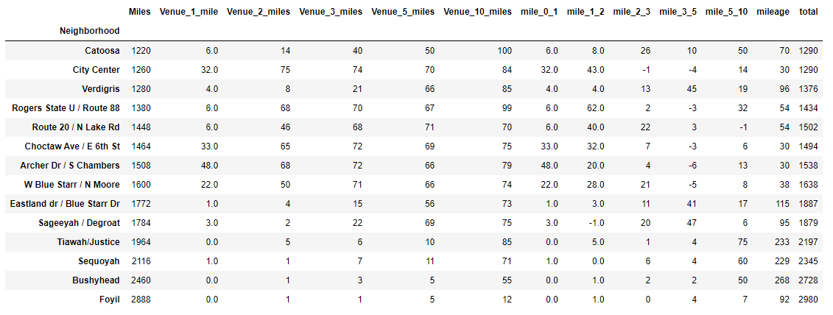

4. Results

The further a neighborhood is from Claremore (and Tulsa), the fewer venues are available.

For the specific locations in Claremore and Tulsa, the further away a neighborhood is from those locations, the more driving needs to be done.

The distance driven to the 30 closest venues increases as the neighborhoods get distant from Claremore and Tulsa but not so much as to affect the rankings of the total mileage driven for the neighborhoods (but again more driving still needs to be done).

One surprising fact was that moving closer Euclidean distance-wise to Grove, than where the author currently lives, did not lead to shorter driving distance (or driving time) than what it takes him to drive there now (data not shown).

5). Discussion

The decision on which neighborhood to buy a home in, largely depends on the specific locations that need to be driven to on a regular basis and that trumps the distance that needs to be driven to nearby venues at least as far as ranking neighborhoods to total distance driven is concerned.

If one were looking only at total mileage driven, the more distant neighborhoods would only be an option if one was not driving into Tulsa on a regular basis and even then there would be a lot of driving to nearby venues.

Euclidean distance is misleading as far as driving distance is concerned. Being closer physically does not equate to a shorter driving distance or time. In the case of driving distance to Grove, the limited interstate exchanges hinder traveling there from Claremore

6). Conclusion

Need to choose a neighborhood based on many factors but a prime one would be proximity to those specific locations that one needs to travel to.

Living out in the country may be desirable, but it comes at a price in terms of driving distance.

Euclidian distance can be misleading when it comes to driving to a more distant location - Grove, OK.